**DAILY ONLINE ACTIVITIES SUMMARY**

|  |  |  |  |  |  |  |  |  |
| --- | --- | --- | --- | --- | --- | --- | --- | --- |
| **Date:** | **17-06-2020** | | | | | **Name:** | **D Jasmine Joyline** | |
| **Sem & Sec** | **VI Sem A** | | | | | **USN:** | **4AL17CS024** | |
| **Online Test Summary** | | | | | | | | |
| **Subject** | | **Python Workshop Test** | | | | | | |
| **Max. Marks** | | **20** | | **Score** | | |  | |
| **Certification Course Summary** | | | | | | | | |
| **Course** | 1.Pre-Placement Training2.DA and ML workshop | | | | | | | |
| **Certificate Provider** | | | **-** | | **Duration** | | | **4hr** |
| **Coding Challenges** | | | | | | | | |
| **Problem Statement:** Find the smallest positive integer value that cannot be represented as sum of any subset of a given array sorted in ascending order.Write a Java program to find the row, column position of a specified number (row, column position) in a given 2-dimensional array | | | | | | | | |
| **Status:Completed** | | | | | | | | |
| **Uploaded the report in Github** | | | | | **Yes** | | | |
| **If yes Repository name** | | | | | <https://github.com/alvas-education-foundation/D_Jasmine_Joyline/tree/master/daily_progress> | | | |
| **Uploaded the report in slack** | | | | | **Yes** | | | |

Online Test Details:

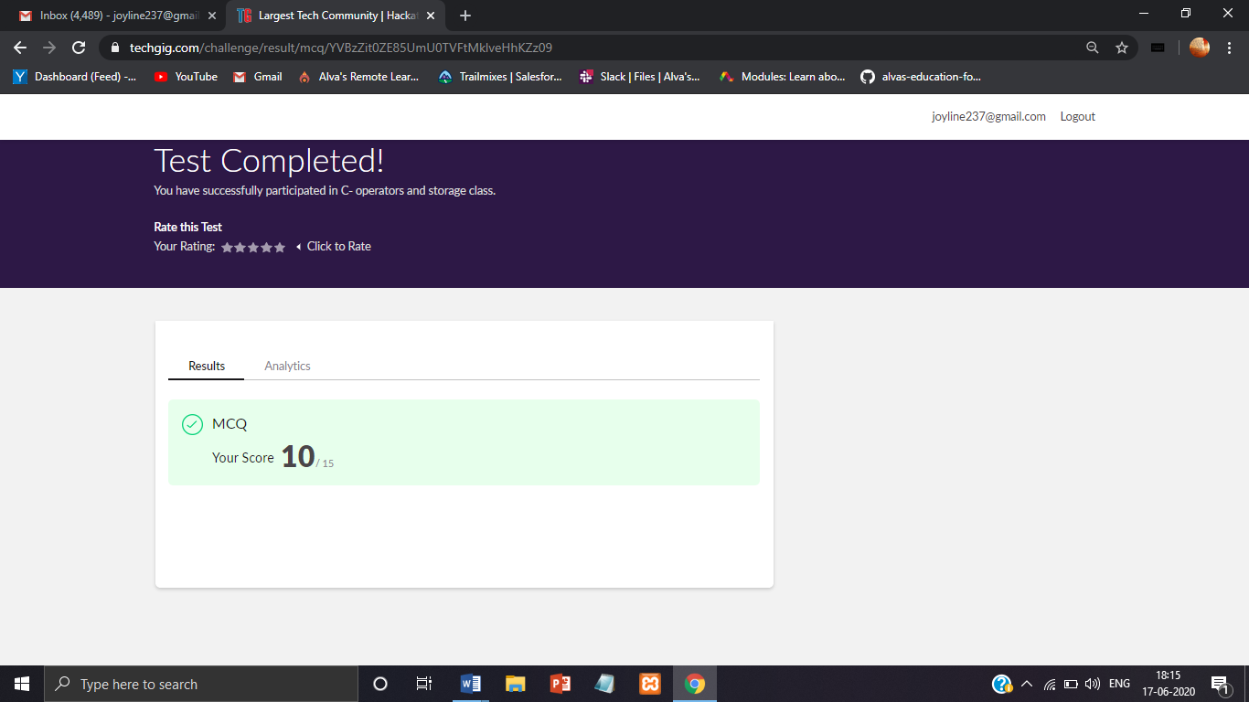

Online Training Details:

Attended class on the topic Programming in C. [from 9am to 11am]

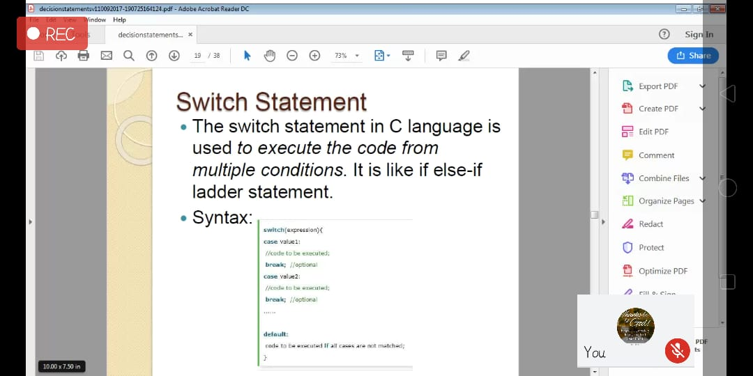

Attended Python Workshop on DA and ML. [from 11am to 1:30pm]

Worked out Python programs using Google Collab.

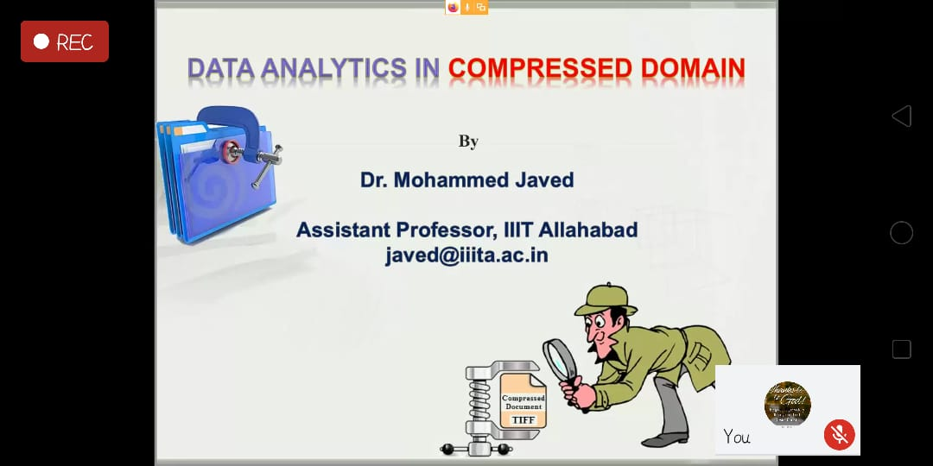

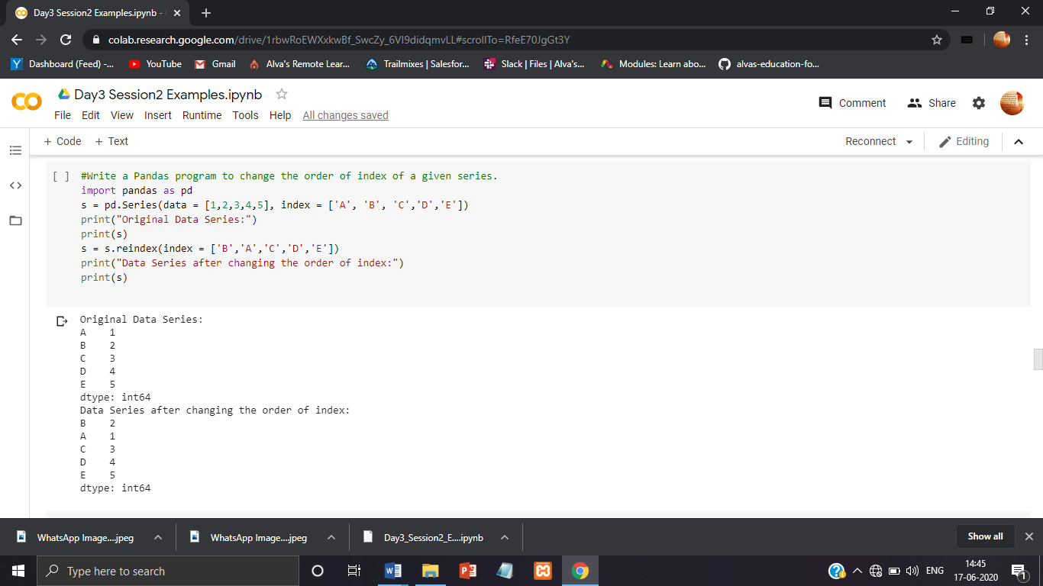

Coding Challenges Details:

## 1.Find the smallest positive integer value that cannot be represented as sum of any subset of a given array sorted in ascending order.

Given a sorted array (sorted in non-decreasing order) of positive numbers, find the smallest positive integer value that cannot be represented as sum of elements of any subset of given set  
Examples:

Input: arr[] = {1, 3, 6, 10, 11, 15};  
Output: 2  
There are no one or more elements to be added up to get sum = 2

Input: arr[] = {1, 1, 1, 1};  
Output: 5  
1 = 1, 1+1 = 2, 1+ 1 + 1 = 3, 1 + 1 + 1 + 1 = 4,  
There is no elements in the array to get sum 5

Input: arr[] = {1, 1, 3, 4};  
Output: 10  
1 = 1, 1 + 1 = 2, 3 = 3, 1 + 3 = 4, 1 + 4 = 5, 1 + 1 +4 = 6, 3 + 4 = 7........  
To get sum 10, there is no elements in the array.

Input: arr[] = {1, 2, 3, 4, 5, 6}  
Output: 22

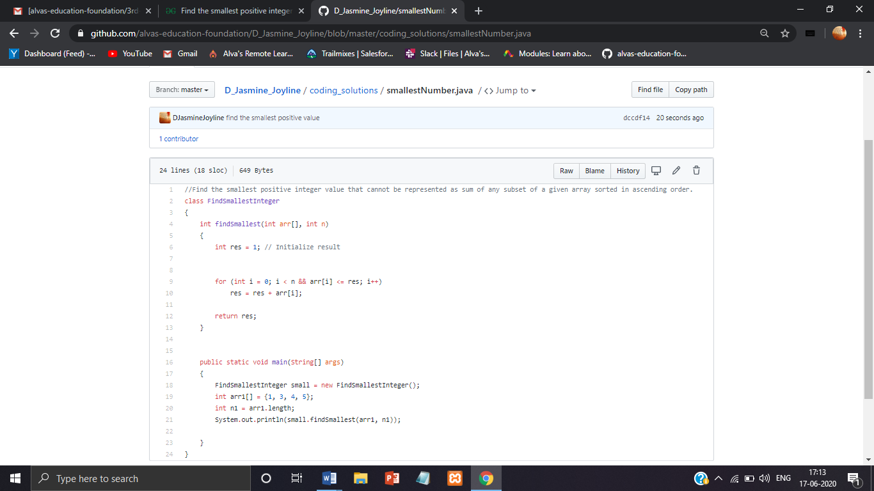

2.Write a Java program to find the row, column position of a specified number (row, column position) in a given 2-dimensional array

